|  |
| --- |
| NSBM Library Management Report |
|  |

|  |
| --- |
| By Runtime terror |



|  |
| --- |
| The library management system |
|  |
| Introduction The library management system is made with an idea of design and in detailed oriented aspect for making the overall manual system at the campus become much efficient .The LMS would allow the daily operation at the library become much efficient , where the librarian and his bulk work of documentation and paper keeping is minimized and now the system is computerized .  The main goal of the project is reduce the burden of manual handling for the librarian and allowing him/her to focus on other activities like maintaining a good library environment , good disciplinary and an area for student to love and enjoy as now lending process is much quicker and faster and making students want to develop good habits for reading.  The following set of requirements are targeting while designing the Library Management system:   1. The Librarian can only search the books by author name and book name. 2. Each book has a unique id for easy reference. 3. There could be more than one book copy and any member can borrow a book. 4. The system will identify the books taken out and when its return back 5. Maximum days allowed per books is 14 or else a fine is charged. 6. The system should collect fines when books returned after 15 days. 7. Each Member card has a unique number which is student Id |

## System Designs

System designing allows the system analysist to develop a visual or graphical model before initializing the development , thereby allows a better presentable idea to the top hierarchy as well as the clients, this allows the project approval to be taken from the top management allowing a successful project proposal to be build , whereas clients understand the concepts much clearly as less technical terms used much meaningful for them . As well as the developers work becomes much simpler and easily doable.

1. **Use case Diagram:** Use case Diagram is a simplest level diagram showing the users interaction with the system that shows the relationship of the use cases and users.

In this particular use case Diagram, we have 2 actors:

1. Librarian (primary actor): Primary actor is the person who initiates the use of the system, where in LMS the librarian is responsible for adding, editing, removing, deleting, reserving, issuing books.
2. Student/Member (Secondary actor): Whereas a passive user where only interact with the system for providing student details, reserving books and checking out.

Some of the use Cases are:

1. Add/edit/remove Book: to remove update or add book item.
2. Search: Search by book name and author name, in Book table
3. Register/Cancel membership: to add a new member or delete one from the existing system,
4. Checkout: to lend a book if the criteria is meet.
5. Return Book: to return book if not return within given time fine is charged .

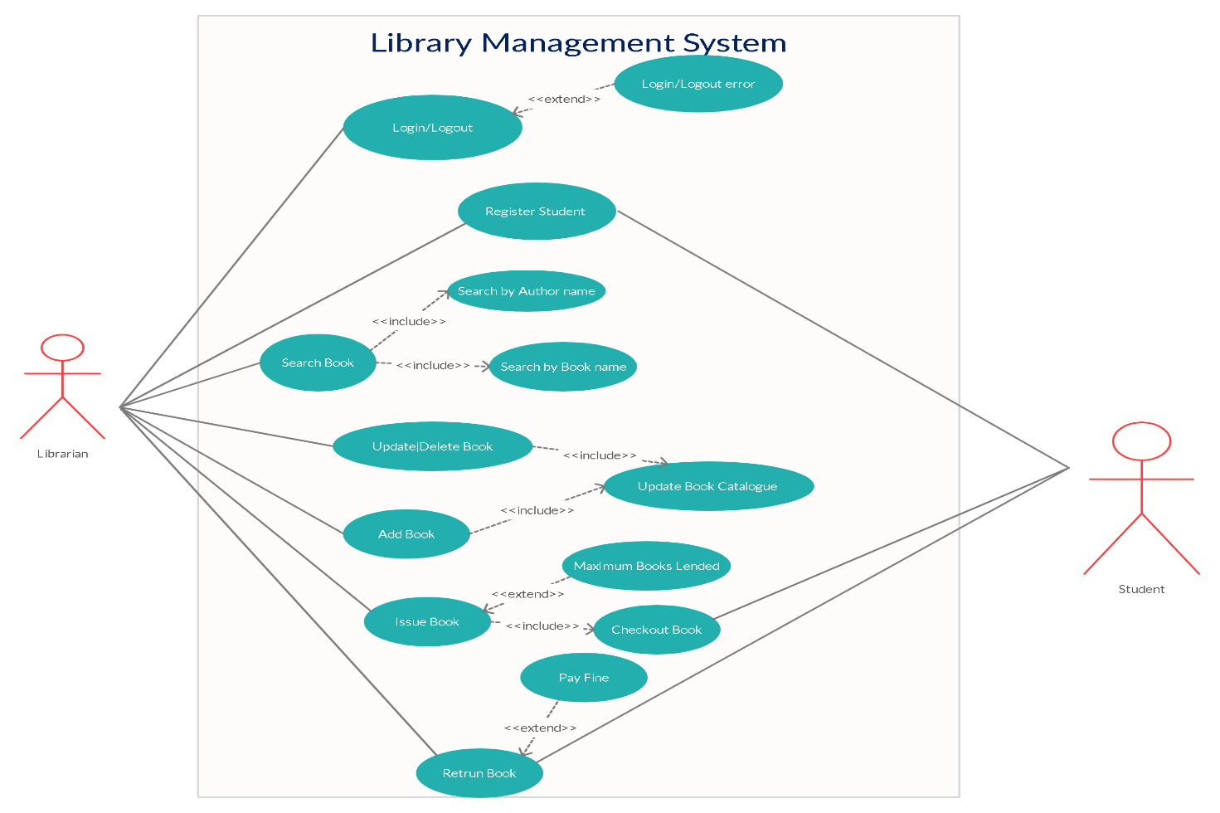

1. **Class Diagram:** Class Diagram is UML Graphical model that’s used to describe the structure of a system by showing system classes, their attributes, functions and relationship among them.

The main classes of the system is:

1. Library: The central part of the organization for which the software is developed for, it has attributes like Name and location which distinguishes it from other.
2. Book: The Basic of the system where it has Book name, Author name, Quantity, price etc.
3. Book item: where any book that has multiple copies will be taught as a book item.
4. Account: We only have one account in here and that’s for the librarian.
5. Library card: All members of the library will be given a card that distinguish identifies all of them.
6. Book Lending: Responsible for book Lending.
7. Catalog: Contains all book details.
8. Fine: Responsible for calculating the fine payable.